On Line Property Search Activity Diagrams

Activity Diagrams:
User Registration Activity

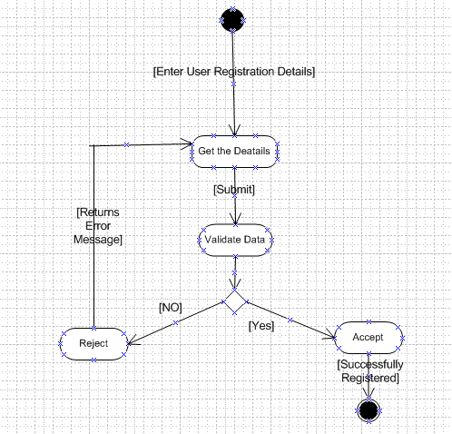

Login Activity:
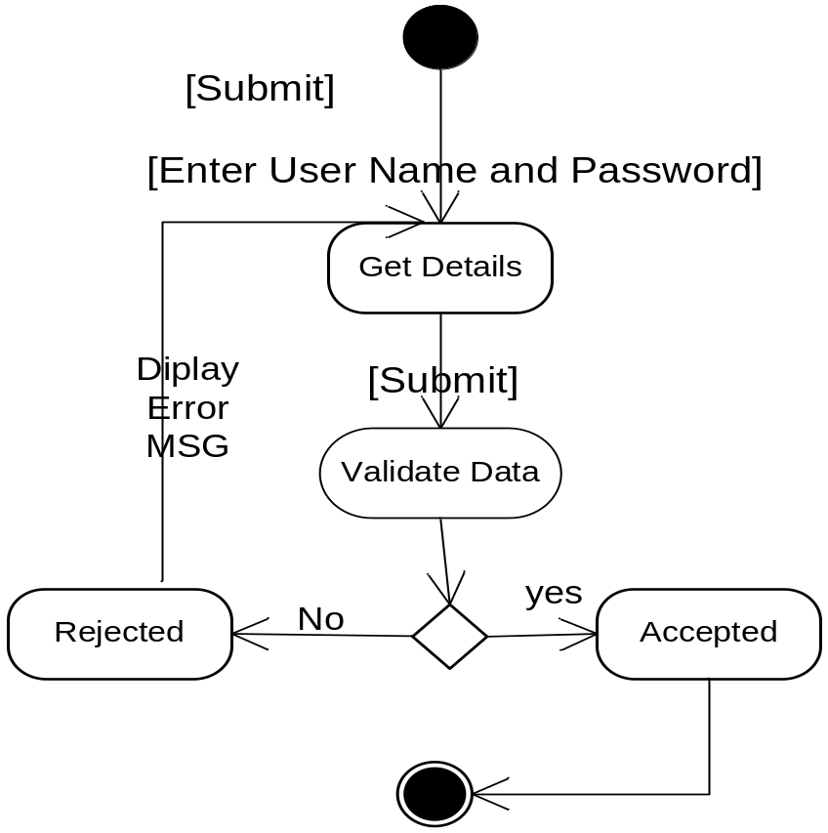
Admin Activities
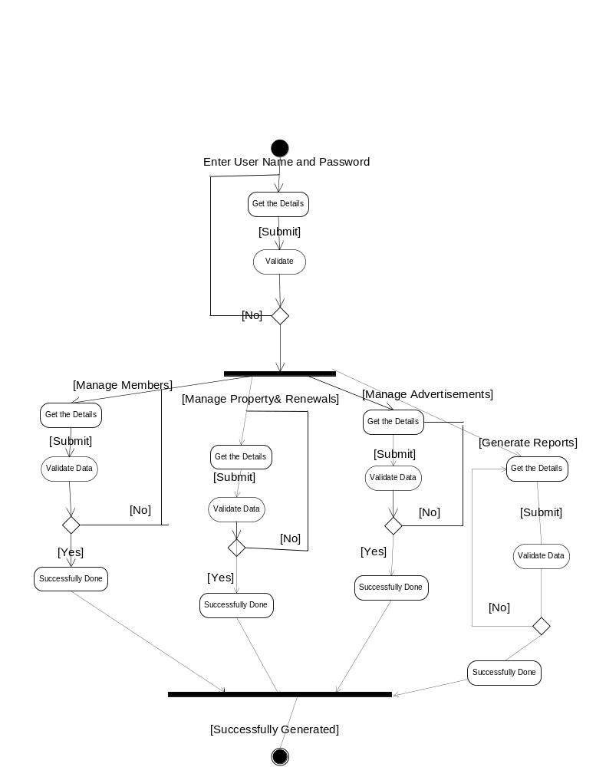
Owner/ Agent Activities
